

#### HUMAN BIOLOGICAL SCIENCES STAGE 2

## **CELL TRANSPORT**

**EXTENDED RESPONSE 3**

Name: ___________________________________

**Cell Transport Extended Response**

1. (i) Label parts A – E of a cell membrane. [5]

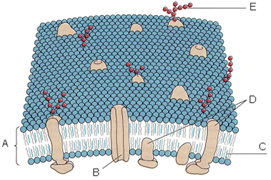

(ii) State the function of part E. [1]

(iii) State the function of part C. [1]

(iv) Through which part of the cell membrane would oxygen normally diffuse? (Select from A – E in the diagram above)

(v) Through which part of the cell membrane would a sodium ion normally diffuse? (Select from A – E in the diagram above)

The following 2 questions relate to the following experiment.

In an experiment, seven cylinders of potato were cut using a cork borer. Each cylinder was then weighed. The cylinders were then placed in separate test tubes as shown in the diagram below. Each test-tube contained a different concentration of sugar solution.

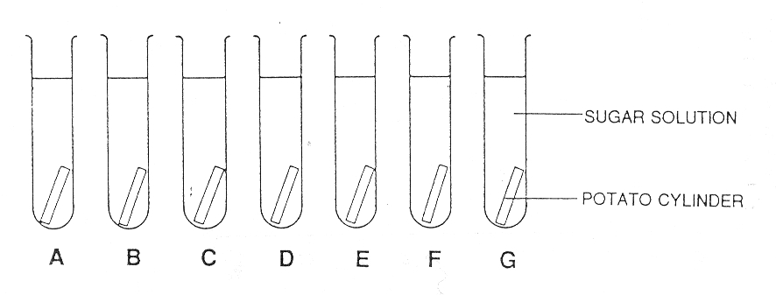

After 24 hours the potato cylinders were removed from the test tubes and carefully dried using a paper towel. They were then weighed again. Some of the potato cylinders gained mass, while others lost mass. The changes in mass are shown in the table below.

|  |  |  |
| --- | --- | --- |
| Test tube | Amount of sugar  in g in 100 cm3  of solution | Increase (+) or  decrease (-) in  mass in g |
| A | 20 | -0.70 |
| B | 18 | -0.40 |
| C | 14 | -0.01 |
| D | 12 | +0.20 |
| E | 10 | +0.30 |
| F | 6 | +0.60 |
| G | 2 | +0.90 |

2. (a) What is the dependent variable in this experiment? [1]

(b) What is the independent variable in this experiment? [1]

(c) Which test tube contained the most concentrated sugar solution? [1]

(d) Which potato cylinder was the most turgid (i.e. full of water)? [1]

3. Consider the potato cylinders that increased in mass. Using your understanding of cellular transport explain what caused this change. [2]

4. Discuss the types of vesicular transport in which materials can move across a cellular membrane. Support your answer with at least two examples. [5]